Cau 1:
- Use diagram
Use case search service information
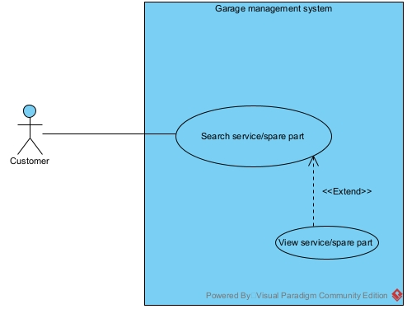
Search service/spare part: this use case enable the customer to search for service and spare part by name
View service/spare part: this use case enable the customer view the detail of a specific service or a spare part
Use case receive payment
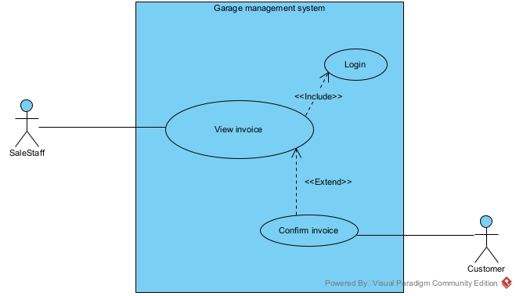
View invoice: this use case enable the sale staff to view all customer invoice, or search invoice by customer name
Login: this use case enable the sale staff to log into the system
Confirm invoice: this use case enable the staff to confirm the payment for an invoice, print the invoice and receive payment
- Scenario:
Use case search service information
Use case | search service information
actor | Customer
Pre-condition | The system has at least 1 service/ spare part
Post -condition | The customer can see the detail of an service
Main events | - The customer access the garage management system  - The system display the main customer interface  - The customer click the view Service/Spare part button  - The system display the view Service/Spare part interface  - The customer enter the service name and click search  - The system display a list of related service/ spare part  - The customer click on a service  - The system display the detail information of that service
Exception | 6. the system display an empty list  6.1 the customer enter the service name correctly and click search again  6.2 the system display the list as in step 6
Use case receive payment
Use case | Receive payment
actor | SaleStaff, Customer
Pre-condition | The system has at least 1 invoice
Post -condition | The sale staff successfully confirm the invoice, and the status is saved to the database
Main events | - The sale staff access the garage management system  - The system display the login interface  - The sale staff enter username, password and click login  - The system display the main staff interface  - The sale staff click the view invoice button  - The system display the view invoice interface  - The sale enter the customer name and click search  - The system display a list of invoice belong to the customer  - The sale staff click on an invoice  - The system display the detail information of that invoice  - The sale staff click confirm  - The system display the confirm invoice interface  - The sale staff click confirm to print invoice, and receive payment
Exception | 4. The system display login error  4.1 the sale staff click ok  4.2 the system display the login interface  4.3 the sale staff enter username, password and click login  4.4 the system display the main staff interface as in step 4  8. the system display an empty list  8.1 the sale staff enter the customer name correctly and click search again  8.2 the system display the list as in step 8

Cau 2:
- Extract entity classes:
Step 1: Describe the system in a paragraph
The system is a garage management system with the main user: management staff, sales staff, warehouse staff, and customers. Each user can interact with the system to do different action. The management staff can view the statistics categories: services, parts, customers, suppliers and service information management, spare parts. Warehouse staff can import spare parts from suppliers, manage supplier information. Sale staff can receive customers, receive service and spare parts requests from customers, assign technical staff according to customer service requirements, receive payment from customers. Customer can search service information, book an appointment online

Step 2: Extract noun
- Related to people: user, mangement staff, sale staff, warehouse staff, technical staff, customer, suppliers
- Related to things: garage, service, part, appointment
- Related to system: interface, statistics, categories, invoice
Step 3: evaluate
- User: create class User: name, phone, address, email, username, password
- Customer: create class Customer
- Sale staff: create class SaleStaff
- Warehosue staff: create class WarehouseStaff
- Technical staff: create class TechnicalStaff
- Supplier: create class Supplier
- Garage: too generic
- Service: create class Service: name, price, description
- Part: create class Part: name, price, description
- Appointment: create class Appointment: date, status
- Interface: too generic
- Statistics: create class CustomerStatistics, PartStatistics, ServiceStatistics, SuppleirStatistics
- Invoice: create class ImportInvoice: date, Invoice: date, total
- Categories: too generic
Step 4: determine the quantity relationship
- Inherit(is a):
  - ManagementStaff, SaleStaff,WarehouseStaff, TechnicalStaff, Customer is a User
- Aggregation(has a):
  - A Appointment has a Customer
  - A ImportInvoice has a Supplier
  - A ImportInvoice has a WarehouseStaff
  - A Invoice has a Appointment
  - A Invoice has a SaleStaff
  - A Appointment has a TechnicalStaff
- Association:
  - Part associate with ImportInvoice create ImportInvoicePart: quantity, price
  - Appointment associate with Service create AppointmentService: price, quantity
  - Appointment associate with Part create AppointmentPart: price, quantity

Step 5: determined quantity relationship:
- Each Customer has many Appointment, 1 ppointment belong to 1 Customer -> 1-n relationship
- Each Appointment has 1 TechnicalStaff, each TechnicalStaff can have many Appointment -> 1-n relationship
- Each Appointment can have many Service, 1 Service can belong in manny Appointment -> n-n relationship
- Each Appointment can have many Part, 1 Part can belong in manny Appointment -> n-n relationship
- Each Appointment has 1 Invoice, each Invoice belong to 1 Appointment -> 1-1 relationship
- Each ImportInvoice has 1 WarehouseStaff, each WarehouseStaff can have many ImportInvoice -> 1-n relationship
- Each ImportInvoice has 1 Supplier, each Supplier can have many ImportInvoice -> 1-n relationship
- Each ImportInvoice can have many Part, each part can be in many ImportInvoice -> n-n relationship
- Each Invoice has 1 SaleStaff, each SaleStaff can have many Invoice -> 1-n relationship
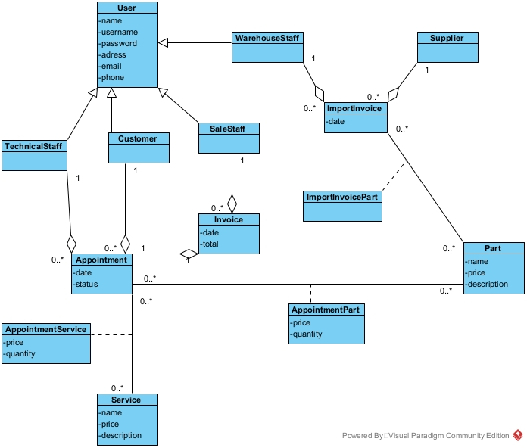
Cau 5:
- Package diagram
The system package are design as follow:
- All Model class are placed in the Model Package
- All DAO class are placed in the DAO package
- All Controller class are placed in the Controller package
- All jsp class are placed in the View package. The View package are further divided as follow:
  - All the jsp class related to Customer are place in the Customer subpackage
  - All the jsp class related to Staff are place in the the Staff subpackage
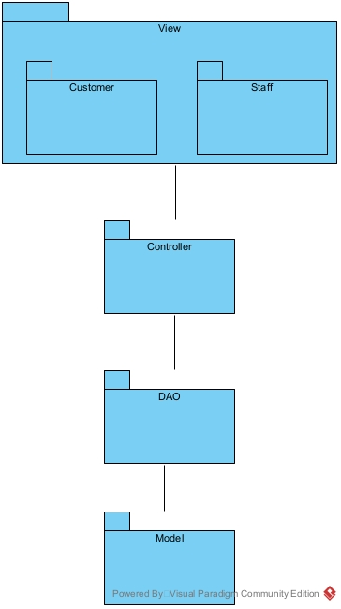
- Deployment diagram
The deployment of the system are designed as follow:
- Client: Many client use browser to send request to the server(Chrome 80+, Edge 78+, Firefow 80+)
- Server: 1 server to handle user request and make queries to the database server (JDK 23, MySQL Connector 8.4.0,JDBC 12.6.1 , Tomcat Apache 10.1.24)
- Database: 1 database to store the data and handle queries(SQL Server 16.0.1160.1)
- Connection:
  - Client <-> Server: HTTP
  - Server <-> Database: JDBC
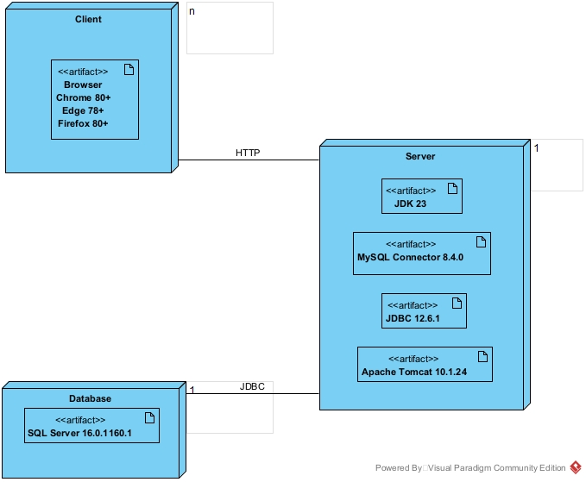
Cau 3:
- Communication diagram
Use case Search service information
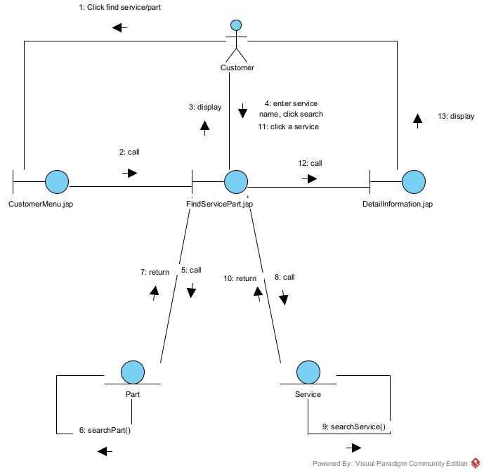
Use case Receive payment
